Online classes happening daily/weekly during this period

Useful for schools and parents who are supporting pupils with learning at home

PE With Joe Wicks  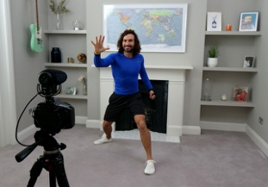 | https://www.youtube.com/watch?v=Uy1yab7jAcU&feature=youtu.be
Music with Myleene Klass  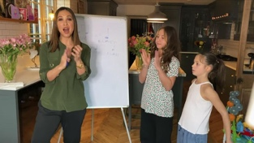 | https://www.youtube.com/channel/UCQh2wgJ5tOrixYBn6jFXsXQ?app=desktop
Maths with Carol Vorderman  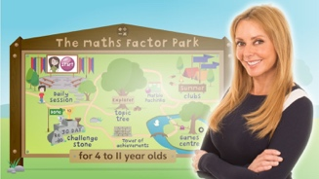 | https://www.themathsfactor.com/
Elevenses with David Walliams  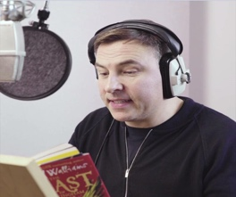 | https://www.worldofdavidwalliams.com/elevenses/
History with Dan Snow | https://www.youtube.com/channel/UC88lvyJe7aHZmcvzvubDFRg
Adventure stories with Ben Fogle  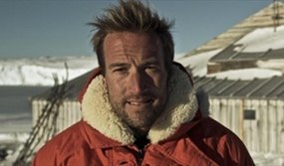 | https://www.instagram.com/benfogle/
The Great Indoors  (Bear Brylls)  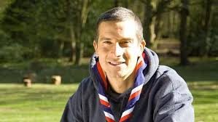 | https://www.scouts.org.uk/the-great-indoors/
Wildlife Q&A with Steve Backshall  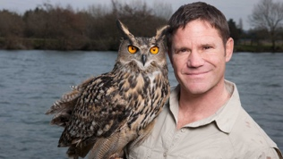 | https://www.youtube.com/channel/UCm-URP49TgSgyIU1rgh2m7A

Science with the ‘stay at home’ festival (Brian Cox Et al)  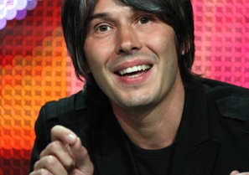 | http://cosmicshambles.com/stayathome
Dance ‘shakeup’ with Darcey Bussell  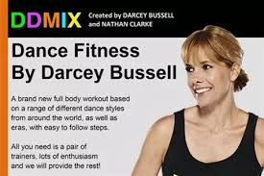 | https://www.facebook.com/diversedancemix/
Cookalong with Theo Michaels  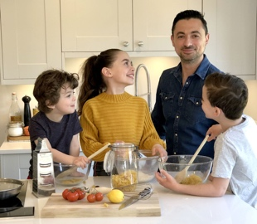 | https://www.theocooks.com/kids-cookalong-live/
Story time with Floella Benjamin  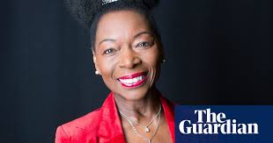 | https://www.youtube.com/watch?v=OTwAb6Z0j2w

