Our new topic is

Here are some activities you can do at home:

- Can you work with your family to build a boat? It can be made from whatever you have at home, can you make sure it floats?

- Can you collect 10 things from around your house. Now can you test if they float or sink? If you have paper, maybe you could find a way to record what floats and what sinks.

- Can you make a telescope from bits you have lying around your home? Now look outside? What can you see?

- Design a pirate flag for your window.

- Can you hide something in your house or garden? Now say or write some clues for someone in your family to help find what you hid.

- Can you draw a treasure map? If you would like the paper to look like a real treasure map, try this the day before:

Rip the edges of a bit of paper to make it look messy.
Dip a teabag in water and drag it all over your paper on both sides.
Leave it to dry or ask a grown up to dry it with a hairdryer.

- Can you use this make up your own pirate names for your family and call each other those names all day?

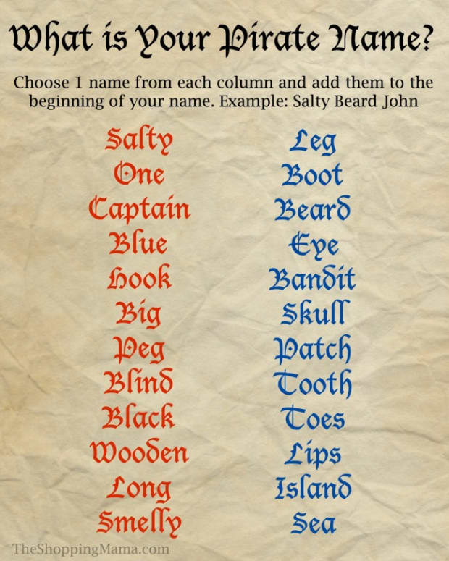

Online you could try these:

https://www.ictgames.com/mobilePage/poopDeck/index.html

https://www.phonicsplay.co.uk/BuriedTreasure2.html#

https://m.youtube.com/watch?v=V7Ew70w-zAM&fbclid=IwAR0sRuo8AMyK5MvWLpe7hVJWE7yPaqiwnreZFD0DSgQMxJwAsLIUIQnSdNg

- Listen to one of these stories and then ask a grown up to ask you some questions about the story. Were you listening carefully?

https://www.youtube.com/watch?v=3a7PJLqPfBA

https://www.youtube.com/watch?v=mdWxBn-xvrQ

https://www.youtube.com/watch?v=VLpC0rUSB18

Look at this picture. How many sentences can you write about what you can see in this picture?
